1. Let’s first understand how linux process runs inside linux environment.
2. **A quick reminder**: Whenever a container is running, it is running inside a “**linux virtual machine**”  
   These containers run as processes inside a linux world even if you run them on MAC or windows.  
   Container is equivalent to linux environment.
3. In the above diagram, we have 3 processes running inside container or really inside of running environment.  
   Every process has 3 communication channels attached to it referring to them as 🡺 STANDARD IN, STANDARD OUT, STANDARD ERR  
   These channels are used to communicate information into the process or out of the process.  
   **STANRDARD IN**: To communicate information into a process.  
    When you type stuff on the terminal, the stuff is directed into the attached STDIN Channel (attached to redis-CLI)  
   **STANDARD OUT**: The standard out might be redirected over to your running terminal and that’s going to end up as being stuff that is going to show up on the screen.  
   **STANDARD ERR**: It’s also very similar but it conveys information out of the process that is kind of like an err in nature.  
   So, if redis-cli has some error inside of it that can be communicated to the outside world over the standard error channel very similar to standard out channel.  
   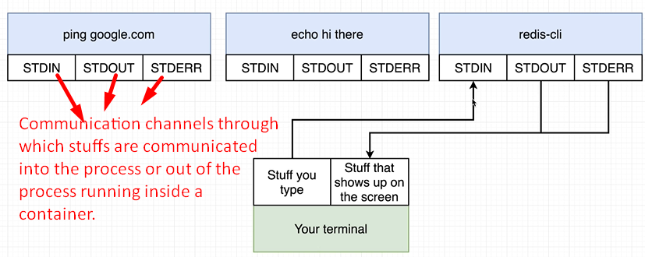
4. So, how do the above channels relate to the –it flag?
5. **Flag i**: When we execute this new command (redis-cli) inside the container, we want to attach our terminal to the STANDARD IN channel of that new running process (redis CLI). By adding this i flag we’re saying make sure that any stuff that I type gets directed to STANDARD IN of REDIS-CLI
6. **Flag t**: To make sure whatever stuff you’re entering and coming out shows up in a nicely manner on your screen.

